Screen 1

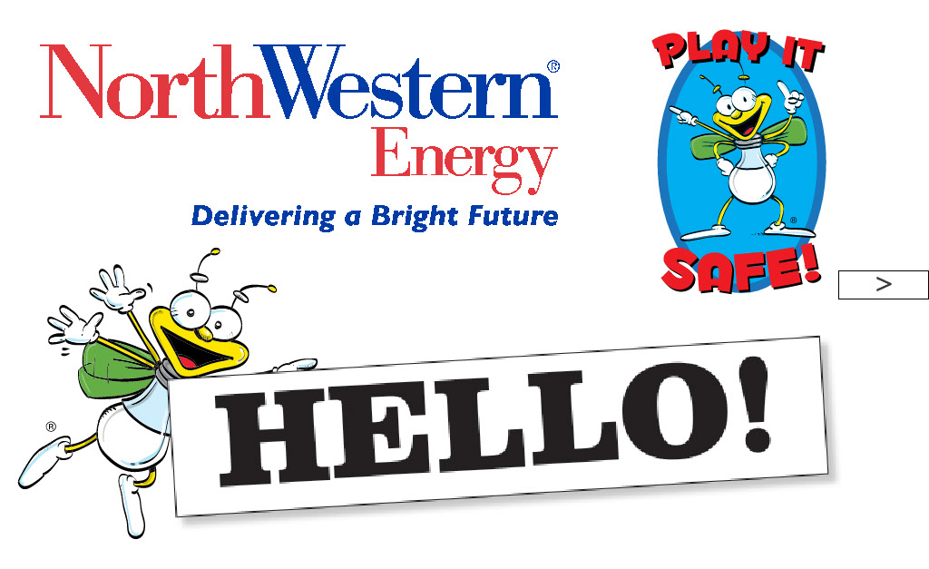

“This presentation is brought to us by NorthWestern Energy.”

Screen 2

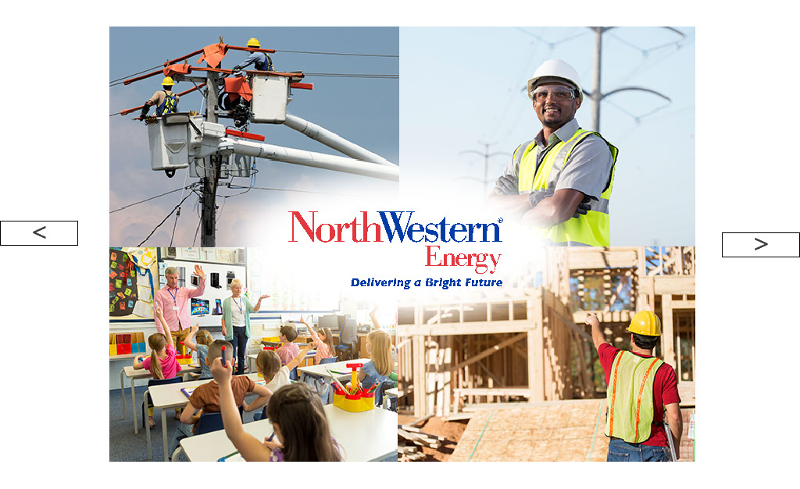

“Does anyone know what NorthWestern Energy makes? They make something that is practically invisible. It’s always in your home and school. And, it’s valuable to all of us.”

[Get suggestions from the students as to what it could be. Someone will eventually guess but if not, just move on.]

“That’s right, electricity!”

“It takes a lot of people to make all that electricity and get it to houses, schools and stores. At NorthWestern Energy, they have people who drive big trucks and climb power poles. They have people who work in power plants that make the electricity. And if the power goes out during a storm, they have people who restore it.”

Screen 3

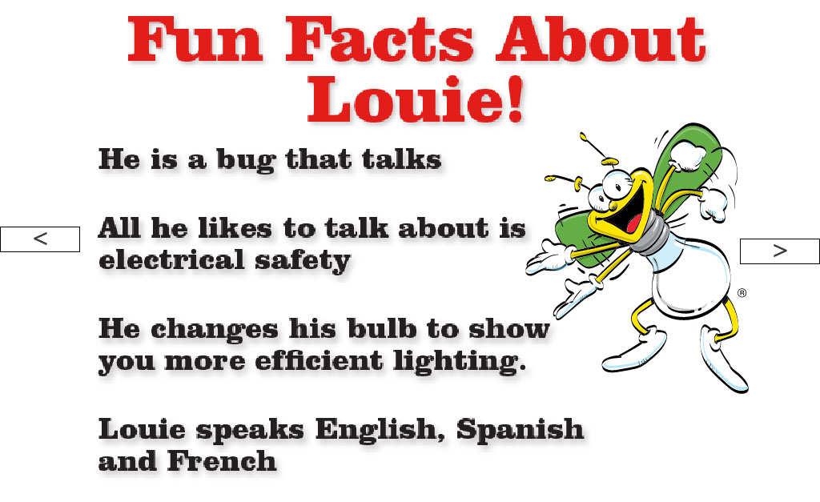

We’ll be seeing a lot of Louie the Lightning Bug today during our presentation. Here are some fun facts about Louie!

- He is a bug that talks.
- All he likes to talk about is electrical safety.
- He changes his bulb to show you more efficient lighting.
- Louie speaks fluent English, Spanish and French.

Screen 4

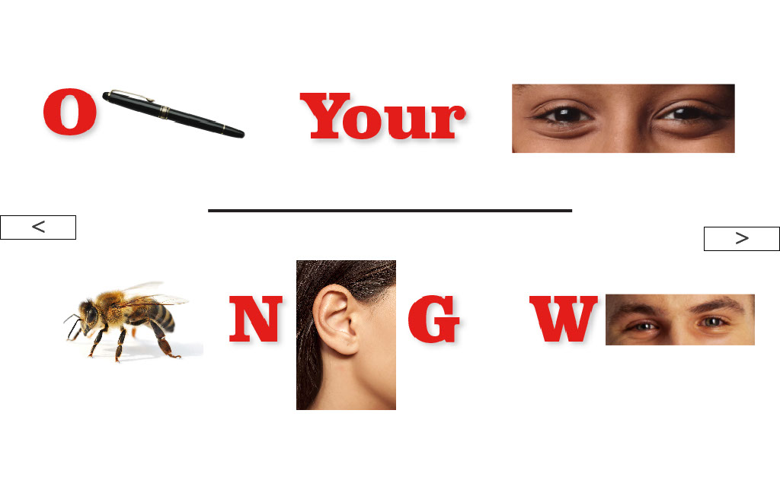

“Can anyone guess what this puzzle says? Each picture makes up parts of words to create an important message for you and your families at home and at school.”

[Work through the puzzle with the students. When they get each word, go to next.]

Screen 5

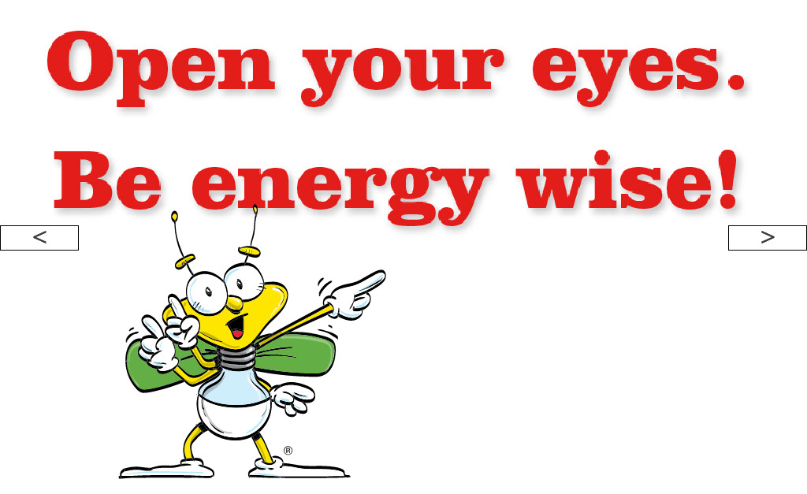

“Let’s all say it together! Open your eyes. Be energy wise!”

Screen 6

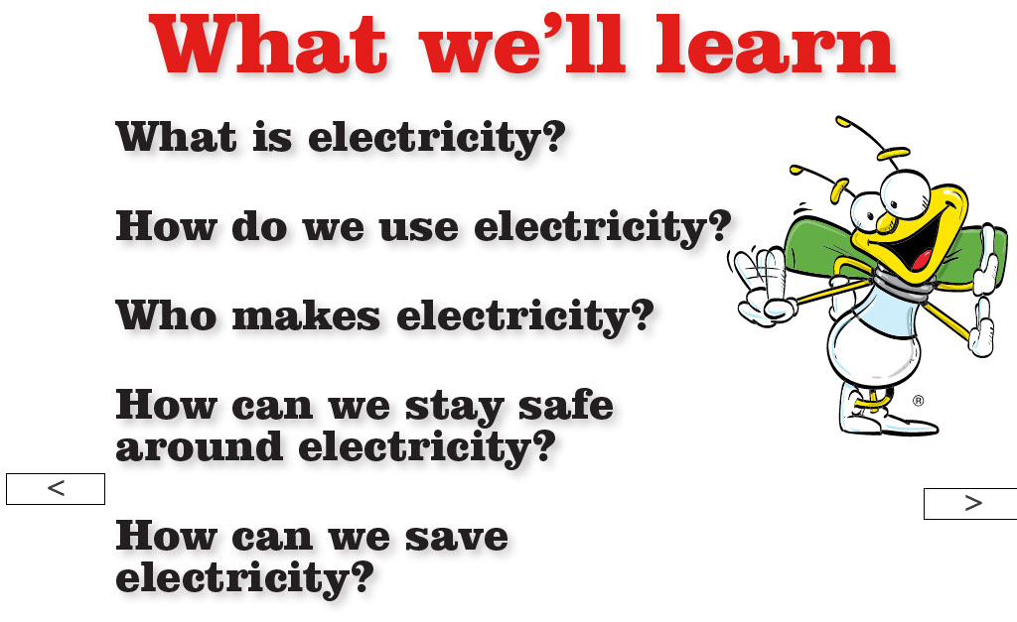

“Today we will learn some very important things about electricity. ” [Read list on screen.]

“Electricity is a form of energy. Electricity is all around us. Lightning is one form of electricity. And during winter when you take off a sweater, then touch something like a doorknob or your friend and feel a little pop on your finger, that’s also a form of electricity---it’s called static electricity. And there is also the kind of electricity that we use every day for all kinds of useful things that make our lives easier.”

Screen 7

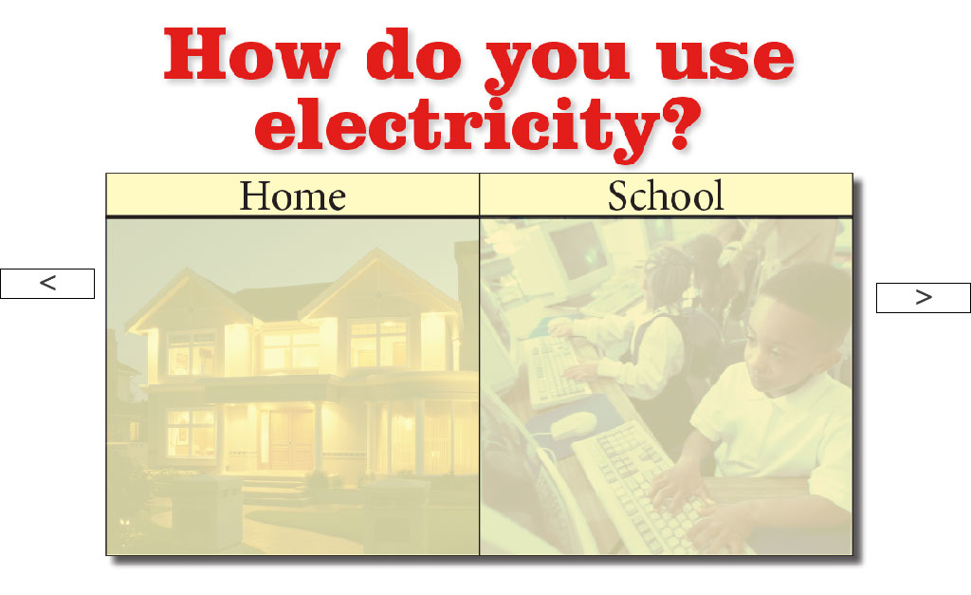

“First, let’s talk about how and where we use electricity. Who can give examples of how we use electricity?”

[As answers slow down, ask how the students’ parents use electricity—drop hints with questions: “How do your clothes get clean?” “How does your dinner get heated?” “What makes your house cool during summer?”]

Screen 8

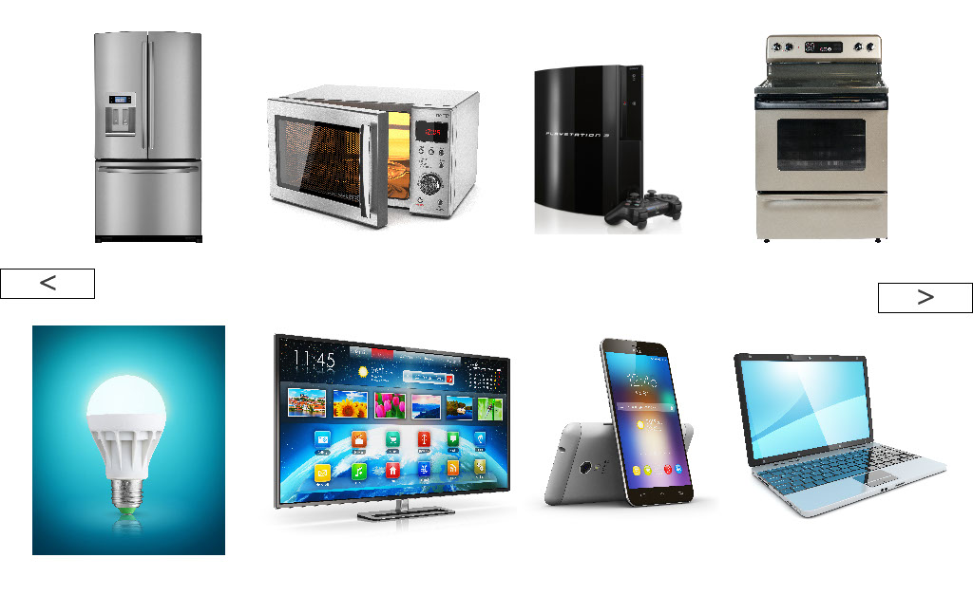

“You are all correct. We use electricity for a million different things! We use electricity in so many ways every single hour of every single day. Now imagine a day without electricity, how would you do all these things?!?”

[Ask the kids how they would go about their day without electricity – where would they keep their food to have breakfast every day? How would they read a book at night? How could they play their video games? Add as many examples as you want.]

Screen 9

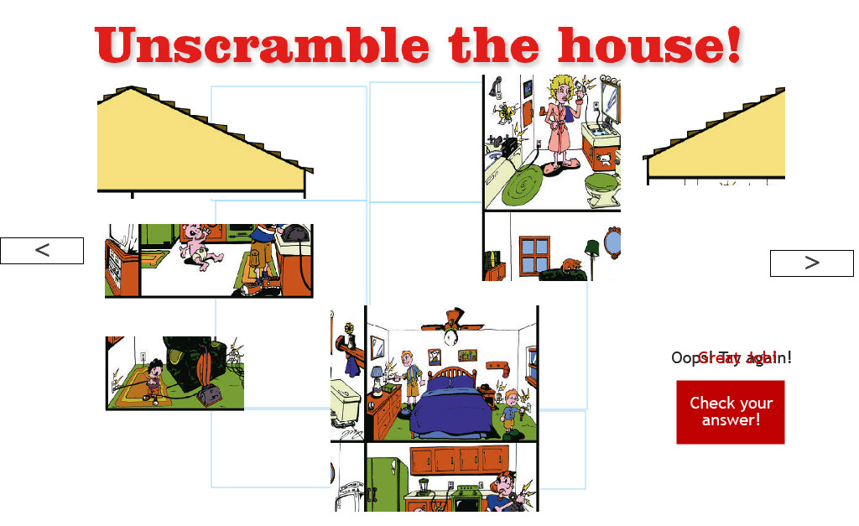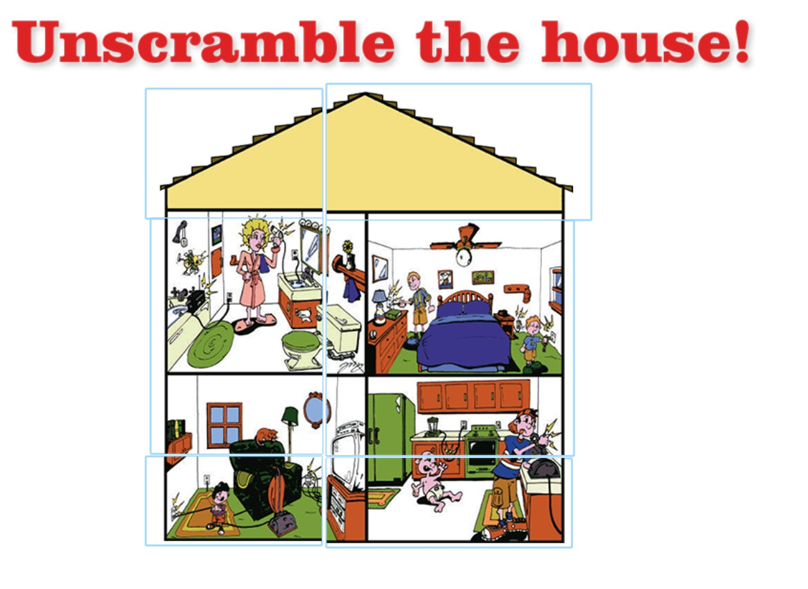

“OK, here is another puzzle, who wants to come up and solve this puzzle? Move the pieces around to put the picture together.”

[After assembling the puzzle, move to discussion about the picture.]

“We use electricity every day but we have to be careful around it. I need your help. Here is a picture of my house, and I have a few dangerous situations at my house. Can anyone spot ways that electricity is not being used safely? Let’s take a closer look in each of the rooms.”

Screen 10

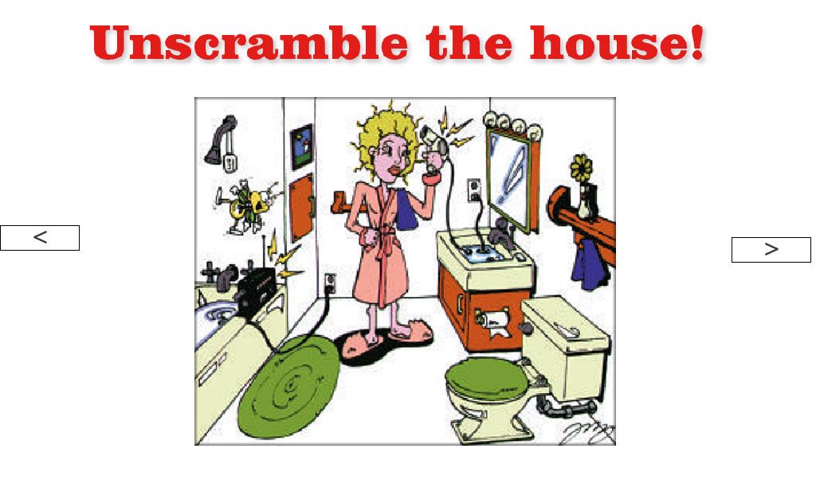

[As the student draws circles around the hazards, identify and explain why each situation is dangerous.]

BATHROOM: radio near bathtub, hair dryer cord in water.

Screen 11

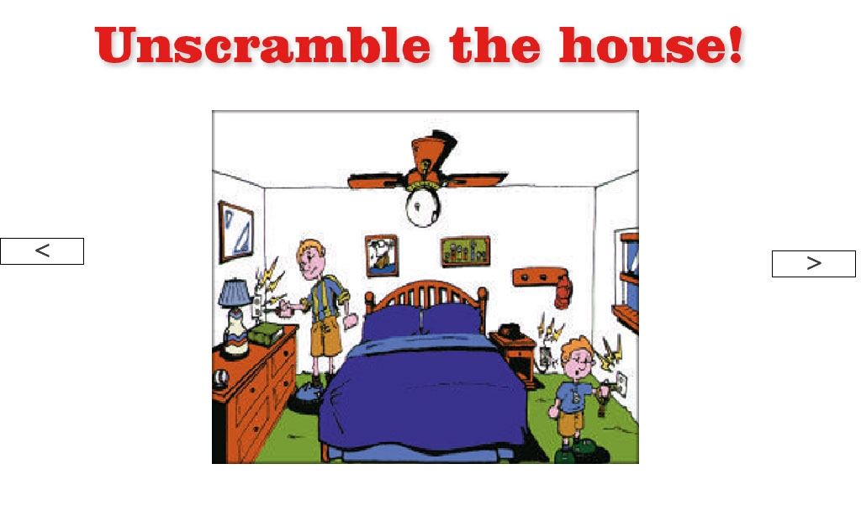

[As the student draws circles around the hazards, identify and explain why each situation is dangerous.]

BEDROOM: keys in outlet, screwdriver in outlet, broken outlet by alarm clock.

Screen 12
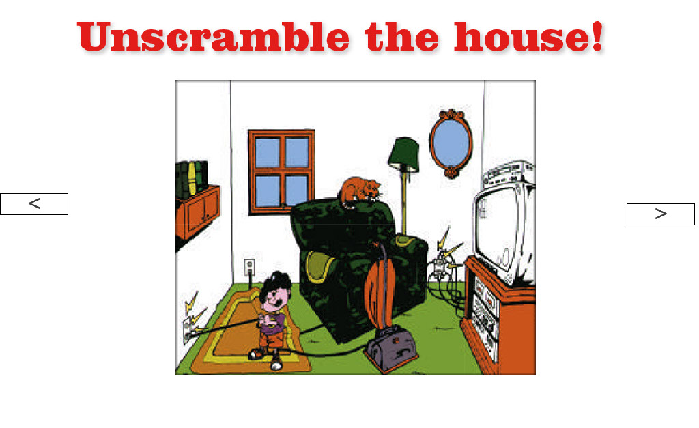

[As the student draws circles around the hazards, identify and explain why each situation is dangerous.]

FAMILY ROOM: overloaded outlet, pulling plug out by cord, electric cord under rug.

Screen 13

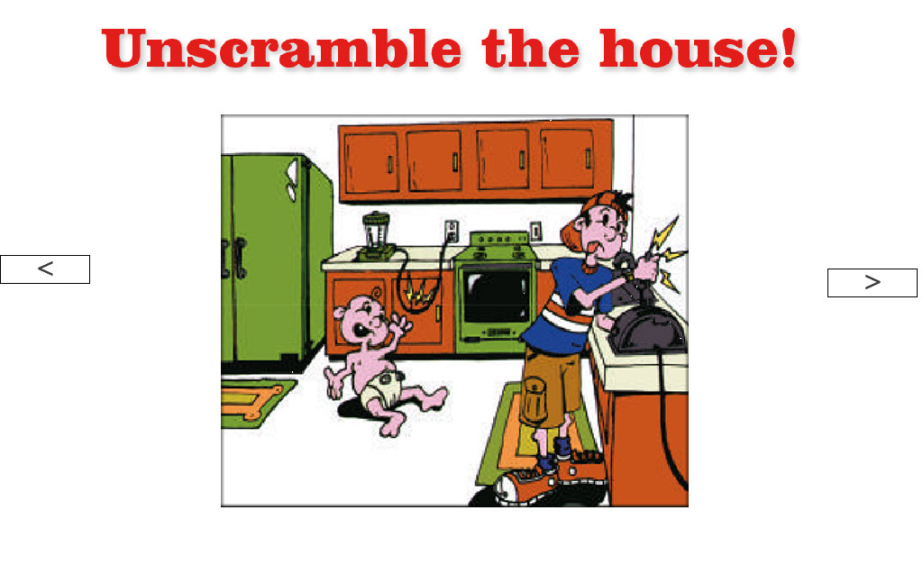

[As the student draws circles around the hazards, identify and explain why each situation is dangerous.]

KITCHEN: fork in toaster, frayed electric cord.
Screen 14

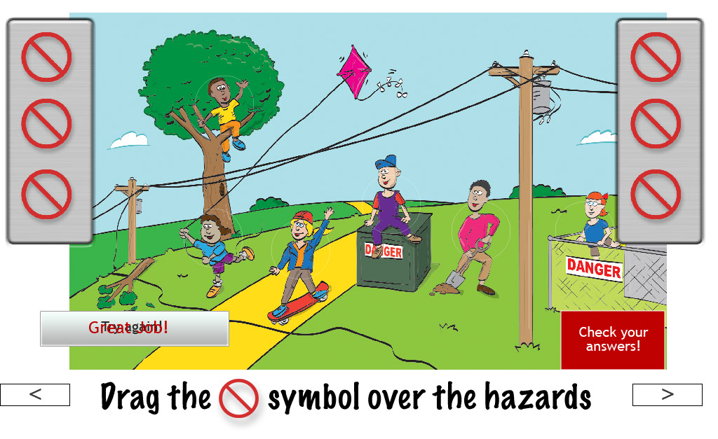

“We also have to be careful around electricity outside. I need some volunteers to drag the ‘don’t do this’ symbol over all the dangerous actions. “

[After all the symbols have been placed:]

“Let’s hit the button to check our answers.”

[Explain why each of the situations is unsafe.]

Flying kite near power lines (discuss overhead line safety)
Digging in ground (discuss underground line safety – can explain 811 call before you dig)
Entering substation
Climbing trees near power lines
Wire down (never touch a downed wire – can explain that after storms can be hidden in debris)
Sitting on transformer - Never go near dangerous equipment

Screen 15

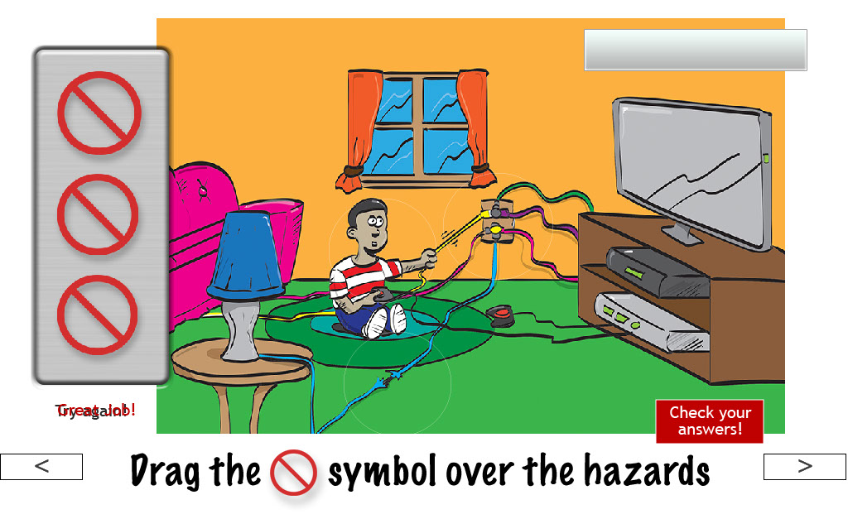

“Let’s go back inside the house for a minute. It looks like we may have some unsafe situations in the living room. Our friend here needs to pause his game and take care of the hazards. Who can help find them? I need three volunteers to drag the ‘don’t do this’ symbol over the safety hazards.”

[After all the symbols have been placed:]

“Let’s hit the button to check our answers.”

[Explain why each of the situations is unsafe.]

Overloaded outlet – can explain what a power strip is
Frayed wire – fire hazard, could get electrocuted
Unplugging by tugging on cord

Screen 16

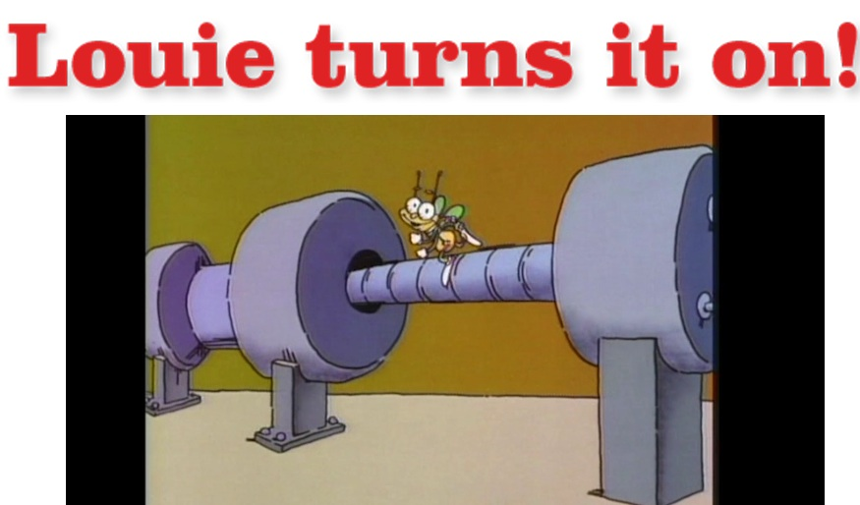

“Did you ever wonder where all that electricity comes from? Our friend Louie the Lightning Bug is here to give us a crash course!”
[Show the Louie TV spot.]

Screen 17
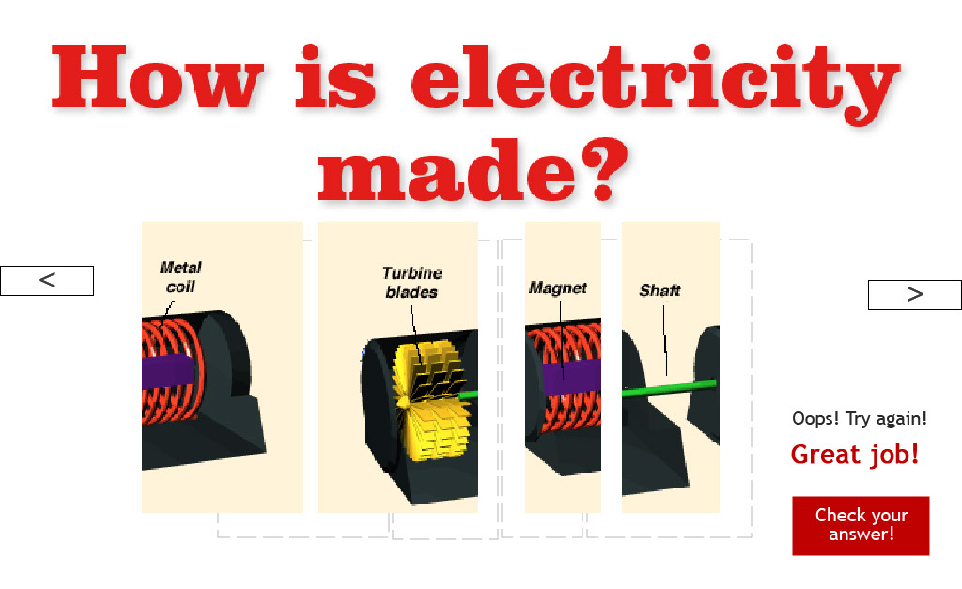

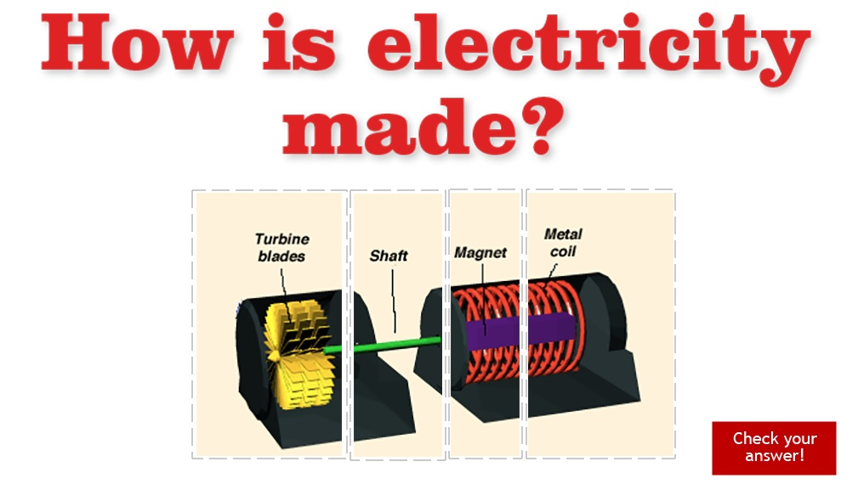

“OK, here’s another puzzle! This one will tell us the basics of how electricity is made. Who can help solve the puzzle?”

[Have student arrange the puzzle pieces and hit the “Check your answer” button.]

“To make electricity, a force turns turbine blades---the blades can be turned by moving water or wind or steam from heated water. The turbine spins a shaft with a huge magnet on it. The magnet is inside a metal coil. The spinning magnet inside the metal coil makes the electricity.”

Screen 18

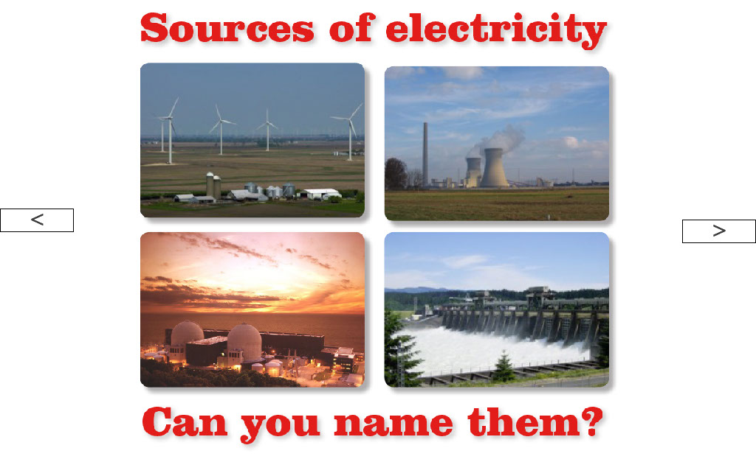

“Here are pictures different ways that we make electricity in our area. Can anyone name the ways?”

[Briefly explain each of the different sources.]

“Electricity is made at a place called a power plant. At the power plant, workers burn resources such as coal, oil or natural gas to boil water. Sometimes nuclear fuel is used to boil water too. That boiling water turns to steam, which is very powerful. That powerful steam is used to spin the turbine. A turbine is like a giant spinning fan. Attached to the turbine is a magnet surrounded by copper coils. When the magnet spins inside the copper coils, it generates electricity!”

Screen 19

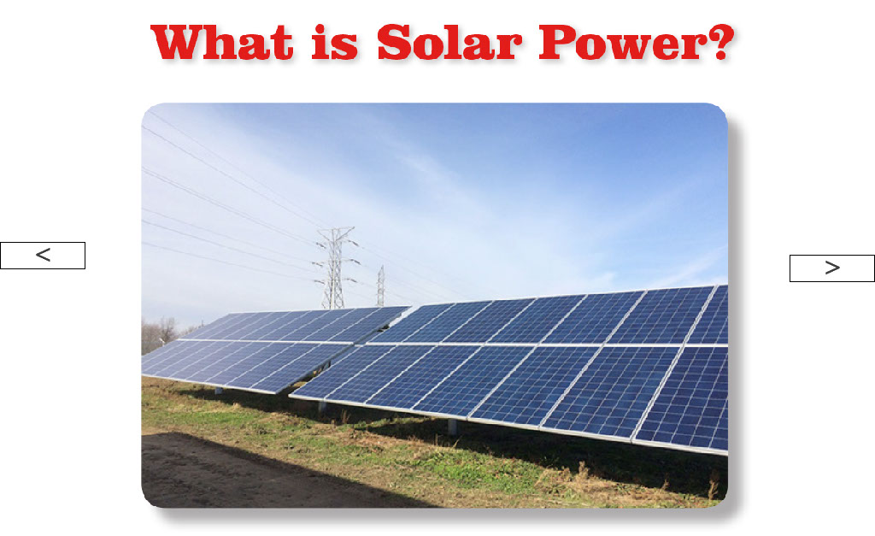

“Does anyone know what makes solar power?” [Wait for answer.] “That’s right. Solar power comes from the sun. These special panels catch the sunlight and convert the sunlight into electricity.”

If they ask for more detail: Most methods of generating electricity involve turning a turbine. But solar generation makes electricity from panels of photovoltaic cells that turn the photons from sunlight into electrons that produce an electric current.

Screen 20

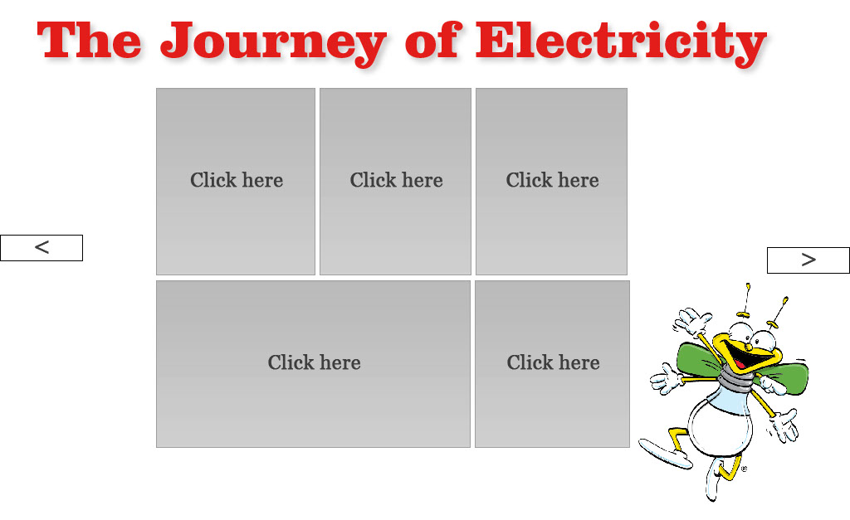
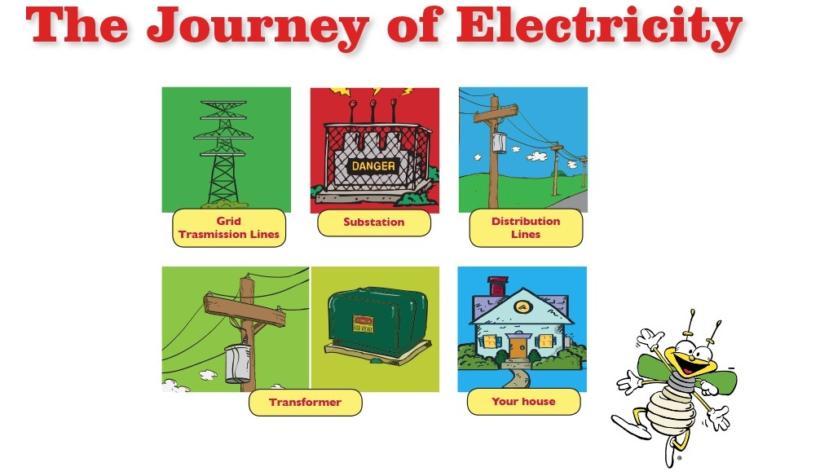

How do you suppose the electricity gets all the way to (insert city where you are)?

“From the power plant, electricity travels along high power transmission lines to substations. At a substation, the electricity is stepped down to a lower voltage of power. From the substation, the electricity travels along power lines, like the kind you see in your neighborhoods, to transformers that are either up on a pole or down on the ground. From the transformers, the electricity then travels along power lines and into the circuit box in your house so you can use the electricity. “

Screen 21

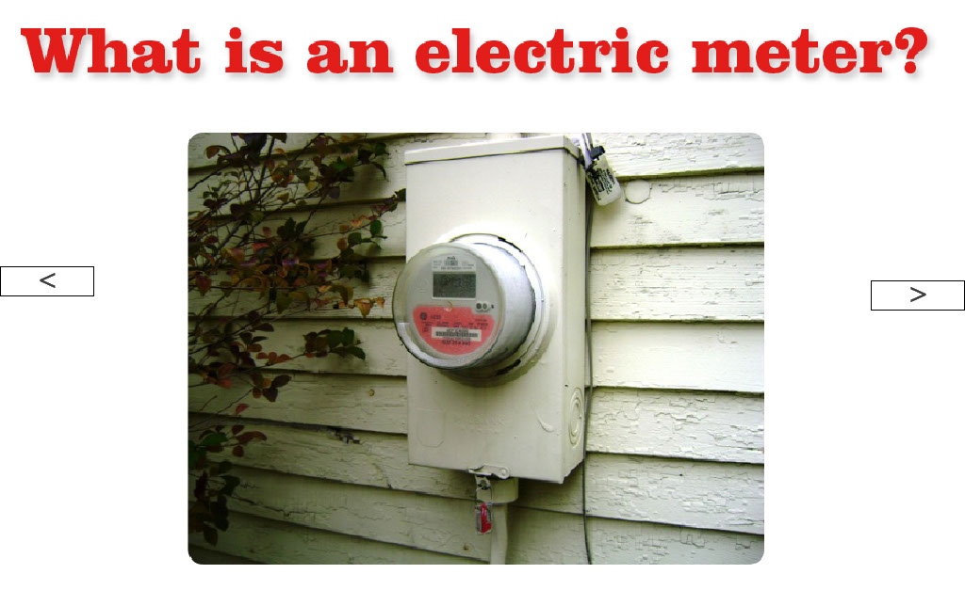

“Has anyone seen one of these on the side of a house or apartment building? This is called an electric meter. It measures the amount of electricity going into the building so the power company will know how much electricity has been used. Every month, people pay for the electricity they used.”

“Have you ever had a parent or teacher tell you to stop wasting electricity? The more electricity you use, the higher the power bill is each month. There are easy ways you can help your family save electricity and have a lower bill each month. Not only will you save help save money but you can help save the earth.”

Screen 22

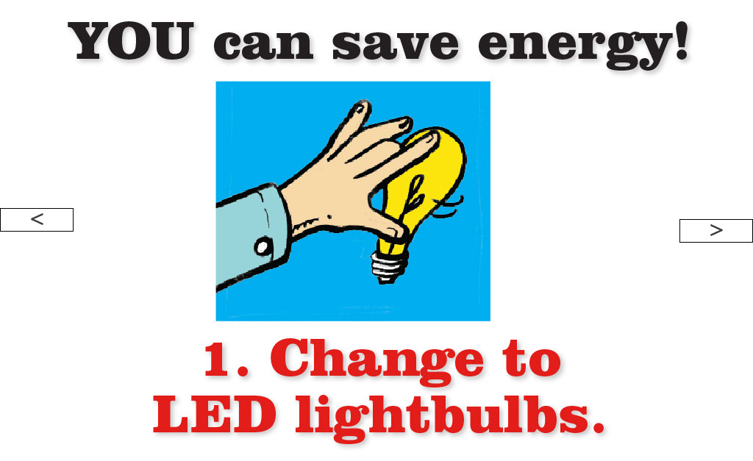

“For many, many years, the types of lightbulbs we used were not energy efficient. They required a lot of electricity to make the light. Scientists created a better lightbulb that are more efficient. The LED bulbs we have today cost less to give the same amount of light and also last much longer.”

Screen 23

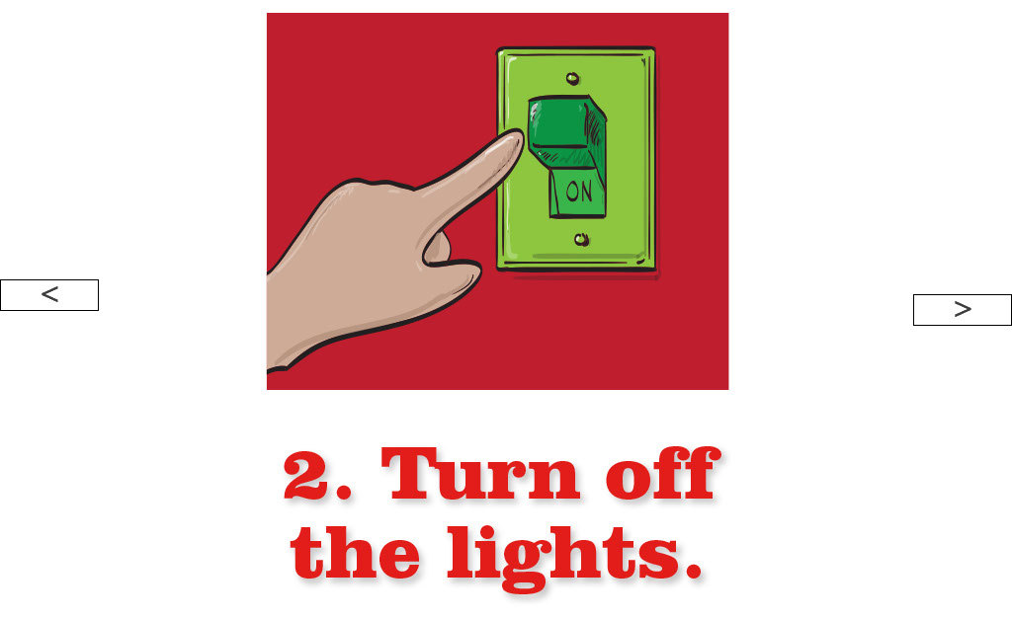

“An easy way to save electricity is to turn off the lights when you leave a room.”

Screen 24

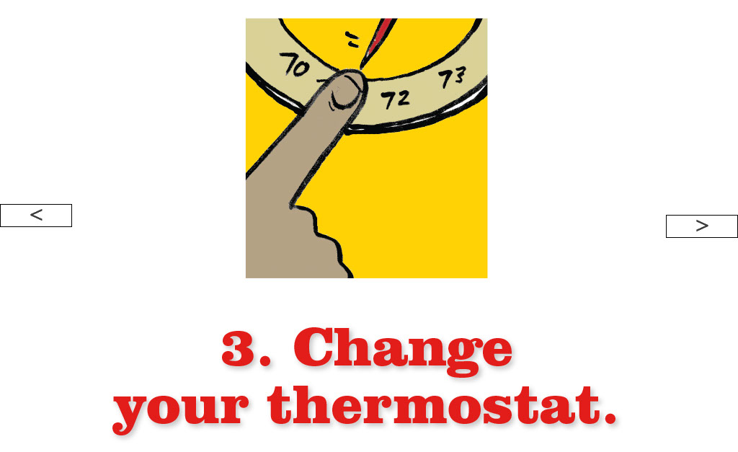

“Did you know that most of the monthly power bill goes toward heating and air conditioning? A small change on your thermostat can make a big difference. When it’s hot outside and the air conditioner is on, set the thermostat a couple of degrees higher than normal so the air conditioner won’t run as much. When it’s cold outside and the heater is on, set the thermostat a few degrees cooler, and stay warmer by wearing warmer clothes in the house.”

Screen 25

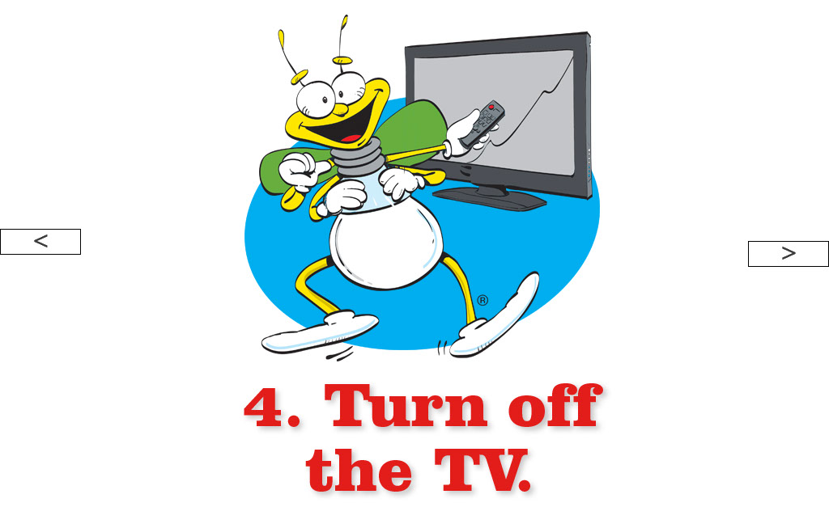

“TVs use a lot of electricity. If you’re leaving the room for a while, turn the TV off while you’re gone. This goes for gaming systems too!”

Screen 26

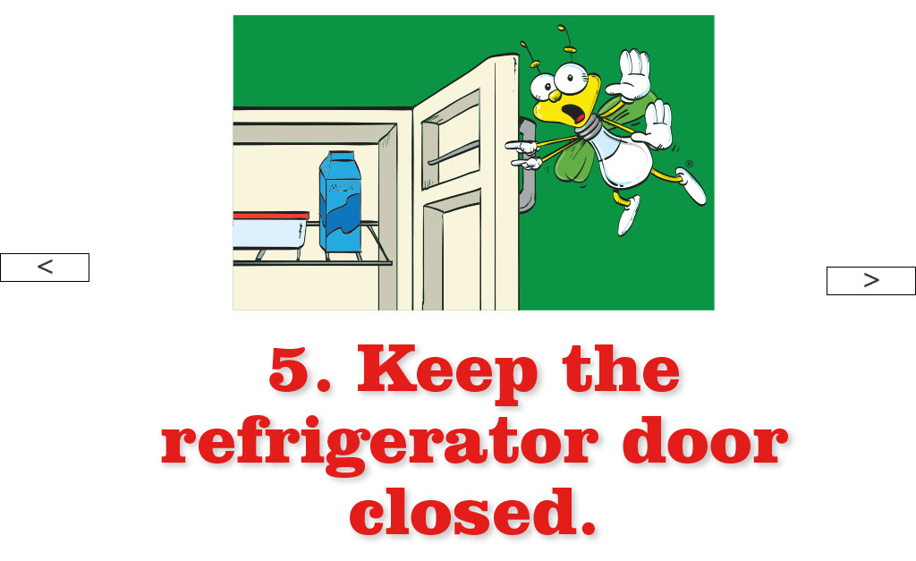
“Standing at the fridge with the door open lets all the cool air out. When you get out that pitcher of juice, shut the refrigerator door while you’re pouring up a glass of juice.”

Screen 27

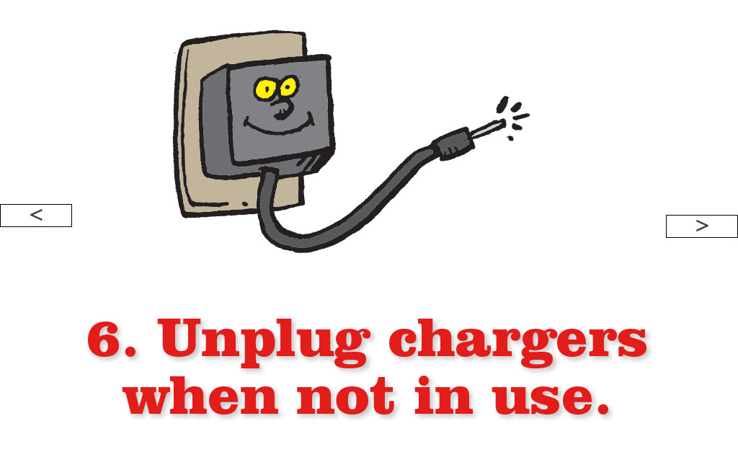

“When left plugged in, electronics chargers use electricity even if your phone or computer or game isn’t hooked up to the charger. When you’re done charging, unplug the charger so it doesn’t waste electricity.”

Screen 28

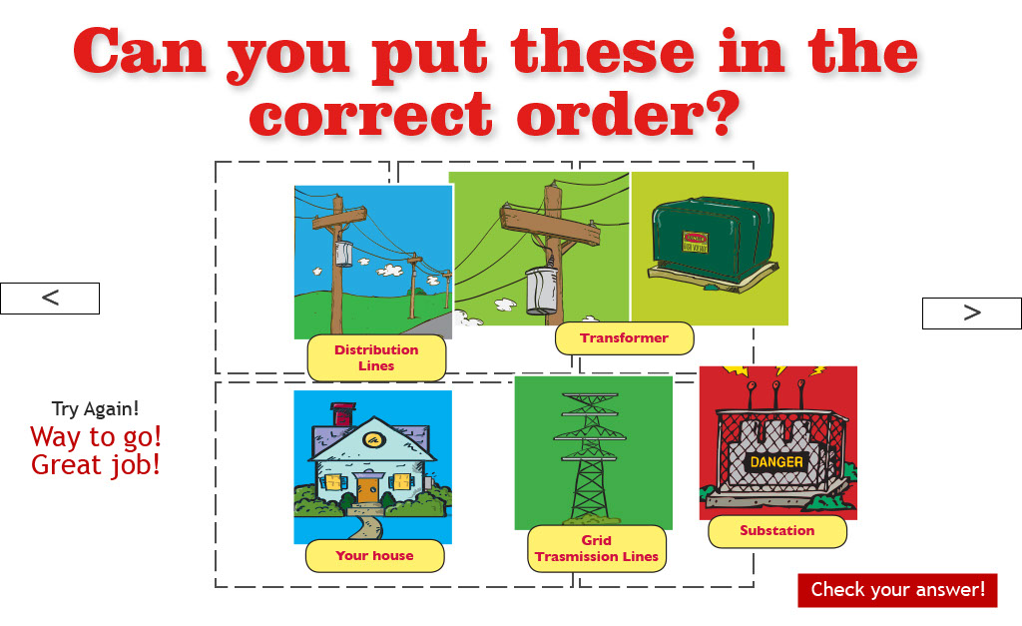

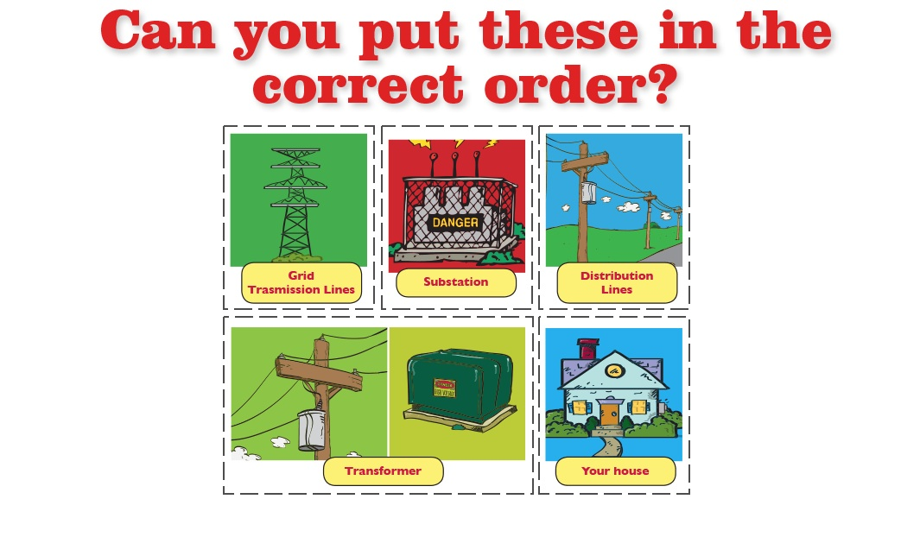

“OK, let’s see how much we remember from the things we talked about today. Who remembers all the steps electricity takes between the power plant and your home?”

Screen 29

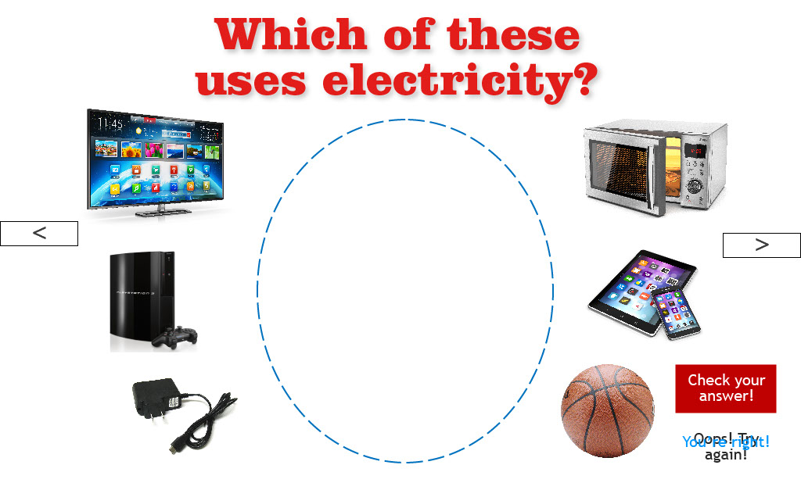

“Let’s drag all of the items that use electricity into the circle, then check our answer.”

Screen 30

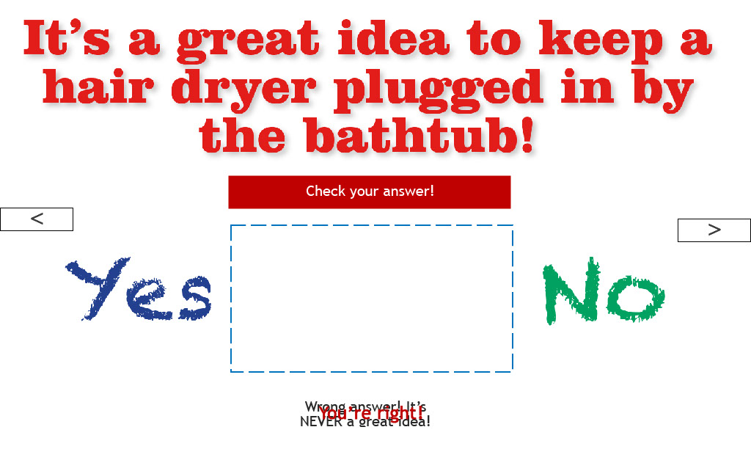

“Any place with water present is a bad place to plug in anything that runs on electricity.”

Screen 31

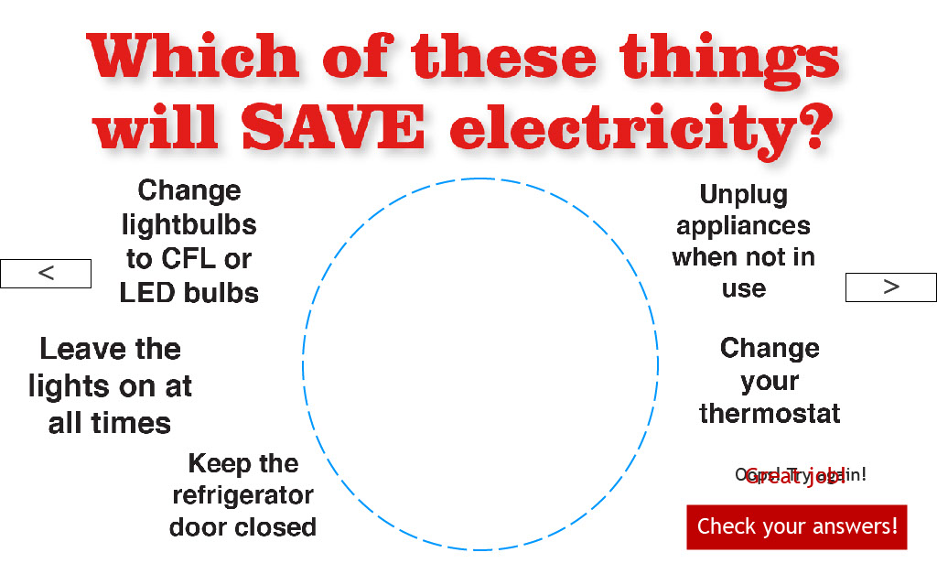

“Drag all of the energy-saving habits into the circle, then let’s check the answer.”

Screen 32

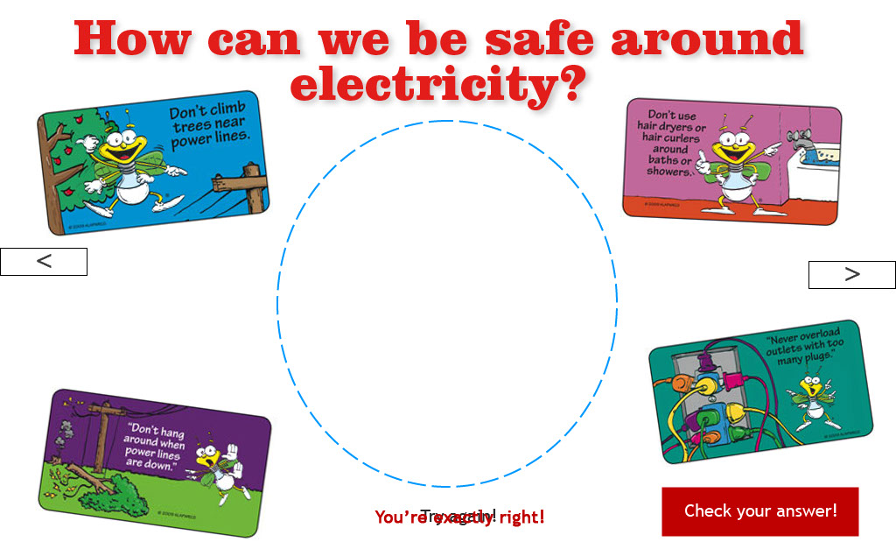

“On this one, let’s drag all of the safety rules into the circle and check our answer.” [Review each safety rule as it is put into the circle.]

Screen 33

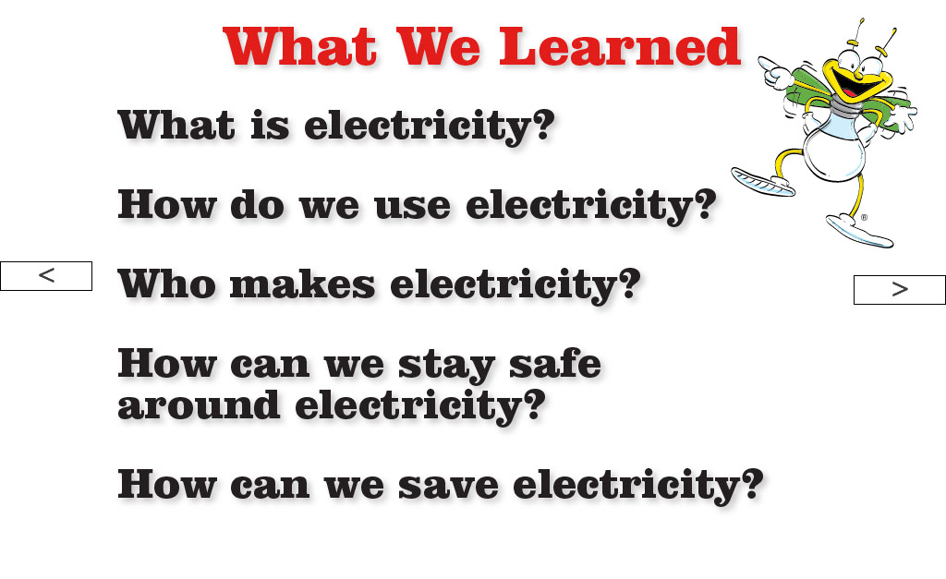
“Great job everyone! Let’s review the main things we learned!

Screen 34

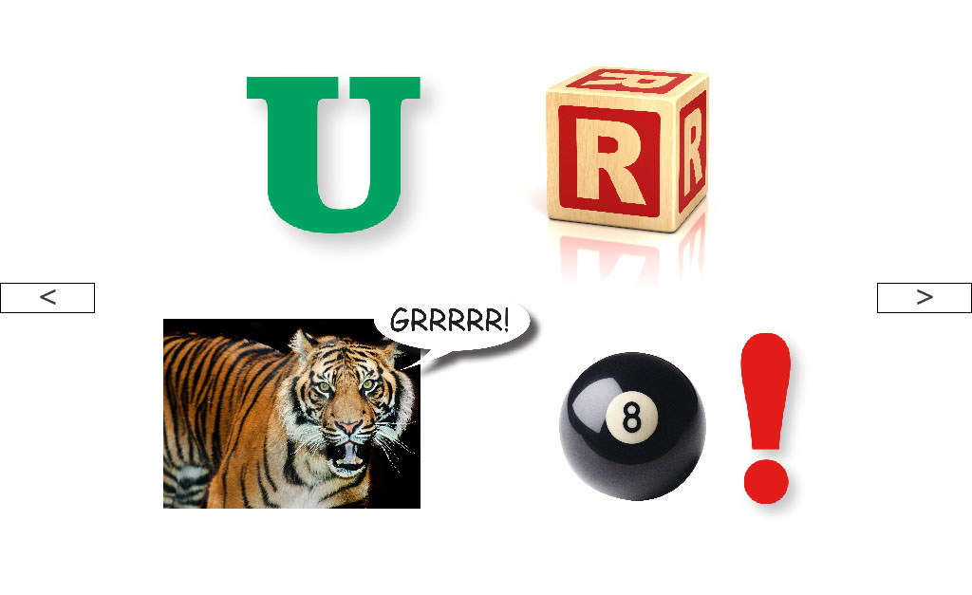
“Let’s do one last puzzle. Let’s sound it out!
You are great!
And always remember to always…”

Screen 35

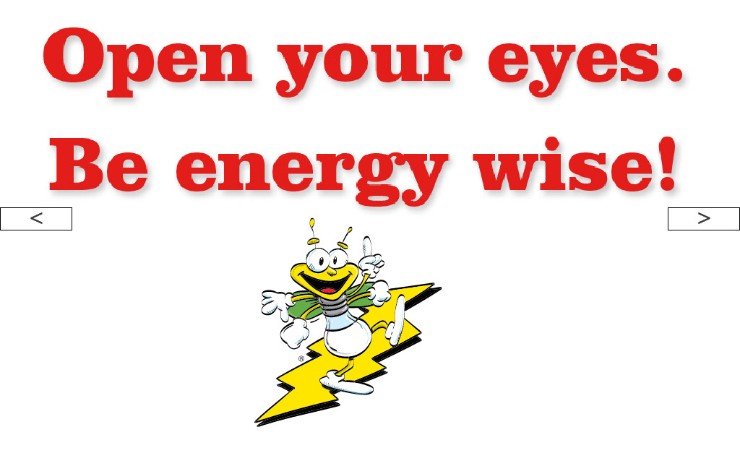
Say it together with the kids.

“Open Your Eyes. Be Energy Wise!”

Screen 36

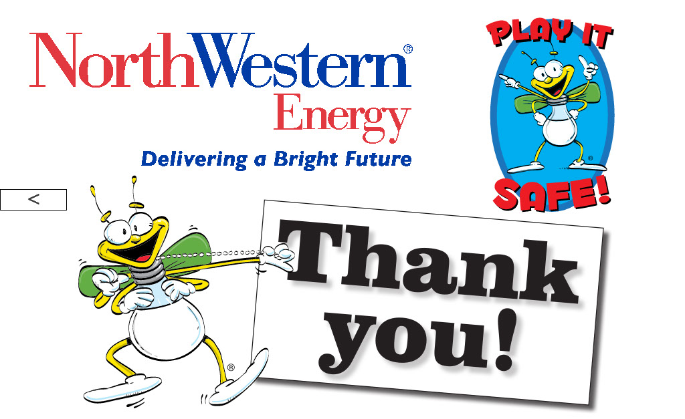

Ask students if there are any questions about the presentation. If you don’t know the answer to the question, you can simply state that you are not sure of the answer.

